Lab Final Assessment (Project) –

Designing Subnetting with CIDR and Implementing a Network Design in CISCO Packet Tracer
Due Date: 9 a.m., Monday, 28th April, 2025

Project Guidelines and Assessment Criteria

Group Size and Contribution Policy
• Each group may consist of a maximum of 3 students.
• Every student must actively contribute to all phases: design, implementation, and reporting.
• Individual marks will be awarded based on the quality and completeness of each member’s contributions.
• Students must clearly mention their individual contributions in the final report under a 'Team Contribution' section.
• Incomplete or undocumented contributions may result in partial or no marks for that section.
Assessment Criteria: Q&A; zero credit will be awarded in case of a no show for the Q&A session.
Deliverables:
- A complete report with analysis, screenshots and routers’ configurations.
- Labelled CISCO Packet Tracer File containing full working implementation of the project.

Assessment Breakdown
Assessment Rubric | Marks | Evaluation Criteria | Name:  Student ID: | Name:  Student ID: | Name:  Student ID:
Design a solution for a computing system | 5 | - Design a subnetting strategy: accurate calculation of subnets, host ranges, and subnet mask  - Correct use of IPs, design interface setup, and end-to-end reachability
Generates a problem solution | 10 | - Implement subnetting in Packet Tracer: correct IP usage, interface setup, and reachability  - Configure RIP or OSPF: protocol setup and routing table verification  - Verify connectivity: successful ping tests and complete routing table output  - Document project: structured report with screenshots, subnet tables, and configs

Assessment Rubrics
Assessment Criteria | Unsatisfactory (1-4) | Needs Improvement  (5-6) | Meets Expectations  (6-8) | Exceeds Expectations  (9-10)
Design a solution for a computing system | The solution lacks coherence or clarity, with insufficient detail provided to understand how the computing system will be designed. Key components or requirements may be missing, and the proposed solution may not address the problem effectively. | The solution outlines a basic plan for designing the computing system but lacks depth or sophistication. Some components may be poorly defined or require further elaboration to fully understand their function within the system. More detail and refinement are needed to enhance the quality and feasibility of the solution. | The solution provides a well-thought-out plan for designing the computing system, including key components, requirements, and implementation strategies. The proposed solution addresses the problem effectively and demonstrates a clear understanding of the system's architecture and functionality. | The solution offers a comprehensive and innovative approach to designing the computing system, incorporating advanced techniques or technologies to optimize performance and functionality. The proposed solution is well-documented and supported by evidence, demonstrating a thorough analysis of the problem and potential design considerations.
Generates a problem solution | The problem solution is unclear or poorly defined, with insufficient detail provided to understand how the problem will be addressed. Key aspects of the solution may be missing or inadequately explained, and it may not effectively resolve the underlying problem. | The problem solution outlines a basic approach to addressing the problem but lacks depth or specificity. Important details may be overlooked, and the proposed solution may not fully resolve the underlying issues or challenges. Further refinement and elaboration are needed to enhance the effectiveness of the solution. | The problem solution presents a well-defined and coherent approach to addressing the problem, including clear objectives, strategies, and implementation steps. The proposed solution demonstrates a thorough understanding of the problem and offers a feasible plan for resolution. | The problem solution offers an innovative and comprehensive approach to addressing the problem, incorporating advanced strategies or techniques to optimize effectiveness and efficiency. The proposed solution is well-supported by evidence and demonstrates a high level of creativity and ingenuity in problem-solving.

Introduction -

Designing Subnetting with CIDR and Implementing a Network Design in CISCO Packet Tracer
Imagine you’ve just been hired as a network designer at a growing organization. Your first big task: design a scalable and efficient IP addressing scheme for the company’s expanding infrastructure!
You will be responsible for dividing a given IP block into subnetworks for various departments across the organization. You get to name and number the departments (e.g., Department 1: HR, Department 2: IT, Department 3: Research, etc.).
You must carefully design your subnets based on the unique requirements assigned to your team, and then implement your design in Cisco Packet Tracer using dynamic routing protocols to simulate a fully functional network. This project is your chance to apply what you've learned and show your skill in real-world network design!

Objective
- Design and implement a subnetting strategy using CIDR to divide a given IP block into equal-sized subnets based on team-specific requirements.
- Configure a network topology in Cisco Packet Tracer with 5–8 subnets, two or more PCs per subnet.
- Configure routers with a dynamic routing protocol (RIP or OSPF).
- Capture all configurations and tests using annotated screenshots.
- Imagine you’ve just been hired as a network designer at a growing organization. Your first big task: design a scalable and efficient IP addressing scheme for the company’s expanding infrastructure!

Subnetting Rules Based on Student IDs:
Enter the right most 3-digits of the student IDs. Read the rules after the table.
GROUP MEMBER CONTRIBUTIONS:
Hassan: Designed the subnet plan, worked out the masks, and put together the IP table.
Yasmin: Built the network in Packet Tracer, configured routing, and saved the device settings.
Maryam: Ran the connectivity checks, took the screenshots, and wrapped up the report.
For the file-transfer app:
Hassan: Wrote the send protocol and added UI feedback.
Yasmin: Created the file-chunking and error-recovery logic.
Maryam: Did the end-to-end tests and collected the results.

 | Sum of the three single digit numbers gives the number of subnets to create | The largest two digit number gives the minimum number of hosts required per subnet
Students Information | 3rd last digit of the student ID | 2nd last digit of the student ID | Rightmost digit of the Student ID
Group Member 1  20230003798  yasmin | 7 | 9 | 8
Group Member 2  20220002085  Hassan | 0 | 8 | 5
Group Member 3  20220002536  Maryam | 5 | 3 | 6
 | Total Subnets: ___12___ | Max of 3 values gives you the min. # of hosts per subnet: ____98_______
- Sum of the leftmost digits of the three group members' student IDs = Number of required subnets (LANs).
- Highest value among the last two digits of all three IDs = Minimum number of hosts required per subnet.
- All subnets can be of equal-size.

Example
Student IDs: 252398, 353112, 751205
- Sum of 3rd last digits: = 3+1+2 =6 subnets required
- Highest rightmost two digits: max(98, 12, 05) = 98 hosts/subnet
- Choose the Given IP Addresses block Accordingly from Class A, B, or C.

1. Subnet Design Summary
Design Parameter | Value
Total Subnets (based on ID rule) | 12
Minimum Hosts/Subnet | 98
Chosen CIDR Block | Since we cannot have exactly 98 hosts, 64 is too little, so we will have 128. Thus, 12 * 128 = 1536.  Class C can only have 256 hosts per network, so Class B must be used, which can have 65,534 hosts.  The CIDR block 172.16.0.0/21 was chosen because a /21 subnet provides 2,048 addresses, enough to accommodate 1,536 hosts. The 172.16.0.0 address belongs to Class B, which suits the required host range.
Subnet Mask | 255.255.255.128/25
Total IPs per Subnet | 128
Usable Hosts per Subnet | 126
Total IPs Needed | 12*128=1536
Address Block Justification | 98 hosts needed in 12 subnets so thats more then class C can have wand with class b too many networks go to waste so with subnets of 128 fixes that issue

2. Subnet Addressing Table (first 5–8 subnets)
Subnet | Subnet Address | First Usable IP | Last Usable IP | Broadcast Address
Subnet 1 | 172.16.0.0 | 172.16.0.1 | 172.16.0.126 | 172.16.0.127
Subnet 2 | 173.16.0.0 | 173.16.0.1 | 173.16.0.126 | 173.16.0.127
Subnet 3 | 174.16.0.0 | 174.16.0.1 | 174.16.1.126 | 174.16.0.127
Subnet 4 | 175.16.0.0 | 175.16.0.1 | 175.16.0.126 | 175.16.0.127
Subnet 5 | 176.16.0.0 | 176.16.0.1 | 176.16.0.126 | 176.16.0.127
Subnet 6 | 177.16.0.0 | 177.16.0.1 | 177.16.0.126 | 177.16.0.127
Subnet 7 | 178.16.0.0 | 178.16.0.1 | 178.16.0.126 | 178.16.0.127
Subnet 8 | 179.16.0.0 | 179.16.0.1 | 179.16.0.126 | 179.16.0.127
 | 180.16.0.0 | 180.16.0.1 | 180.16.0.126 | 180.16.0.127

3. Packet Tracer Implementation
Implement your designed subnets in Cisco Packet Tracer. Each subnet must include at least two end devices (e.g., PCs), and all routers must be configured to interconnect subnets. Use either RIP or OSPF as the dynamic routing protocol. Ensure all routing tables are updated correctly.

4. Configuration Summary Table
Device | Interface | Assigned IP Address | Subnet
Router1 | se0/1/0  fa0/1 | 192.168.0.1/30  172.16.0.1/21 | 255.255.255.252  255.255.255.128
Router2 | se0/0/0  se0/1/0  fa0/1 | 192.168.0.2  192.168.0.5  173.16.0.1 | 255.255.255.252 255.255.255.252  255.255.255.128
Router3 | se0/1/0  fa0/0  se0/0/0 | 192.168.0.6  174.16.0.1  192.168.0.9 | 255.255.255.252  255.255.255.128  255.255.255.252
Router4 | se0/0/0  fa0/1  fa0/0 | 192.168.0.10  192.168.0.13  175.16.1.169 | 255.255.255.252  255.255.255.252  255.255.255.128
Router4 | fa0/0  fa0/1 | 192.168.0.14  176.16.2.1 | 255.255.255.252  255.255.255.128
Router4
Router5

5. Dynamic Routing Configuration (RIP or OSPF)
Summarize your dynamic routing configuration using commands and include screenshots.
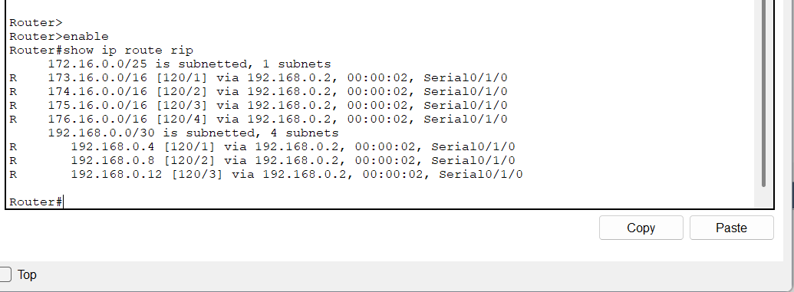
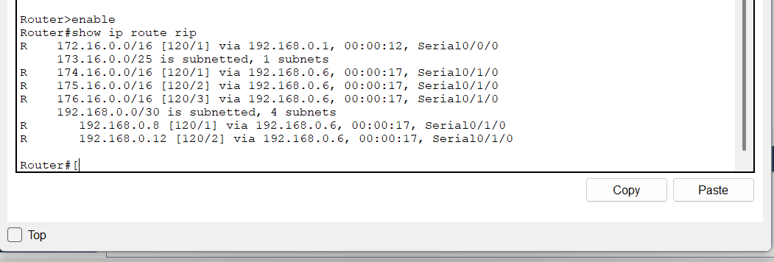
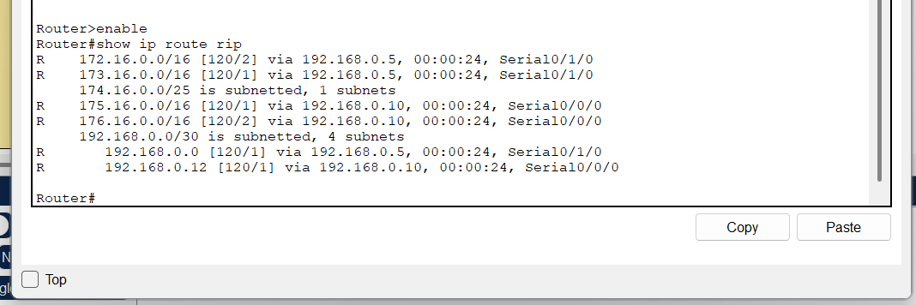

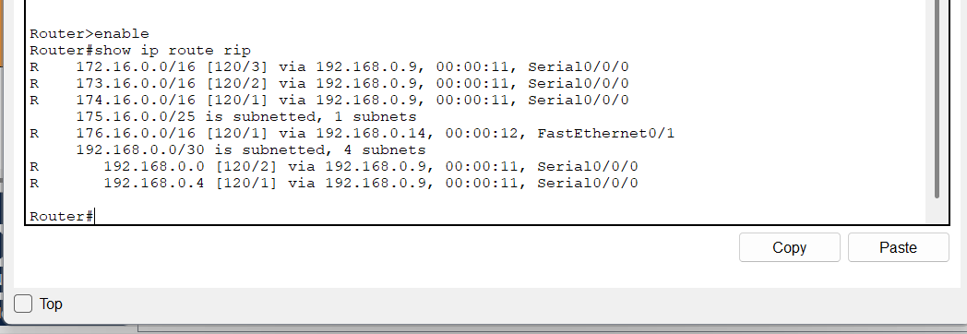

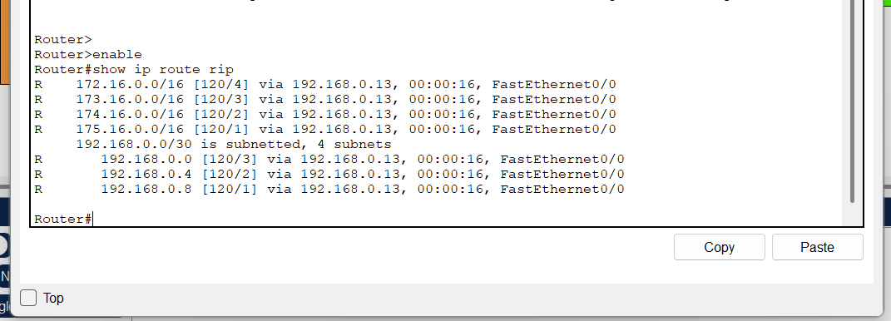
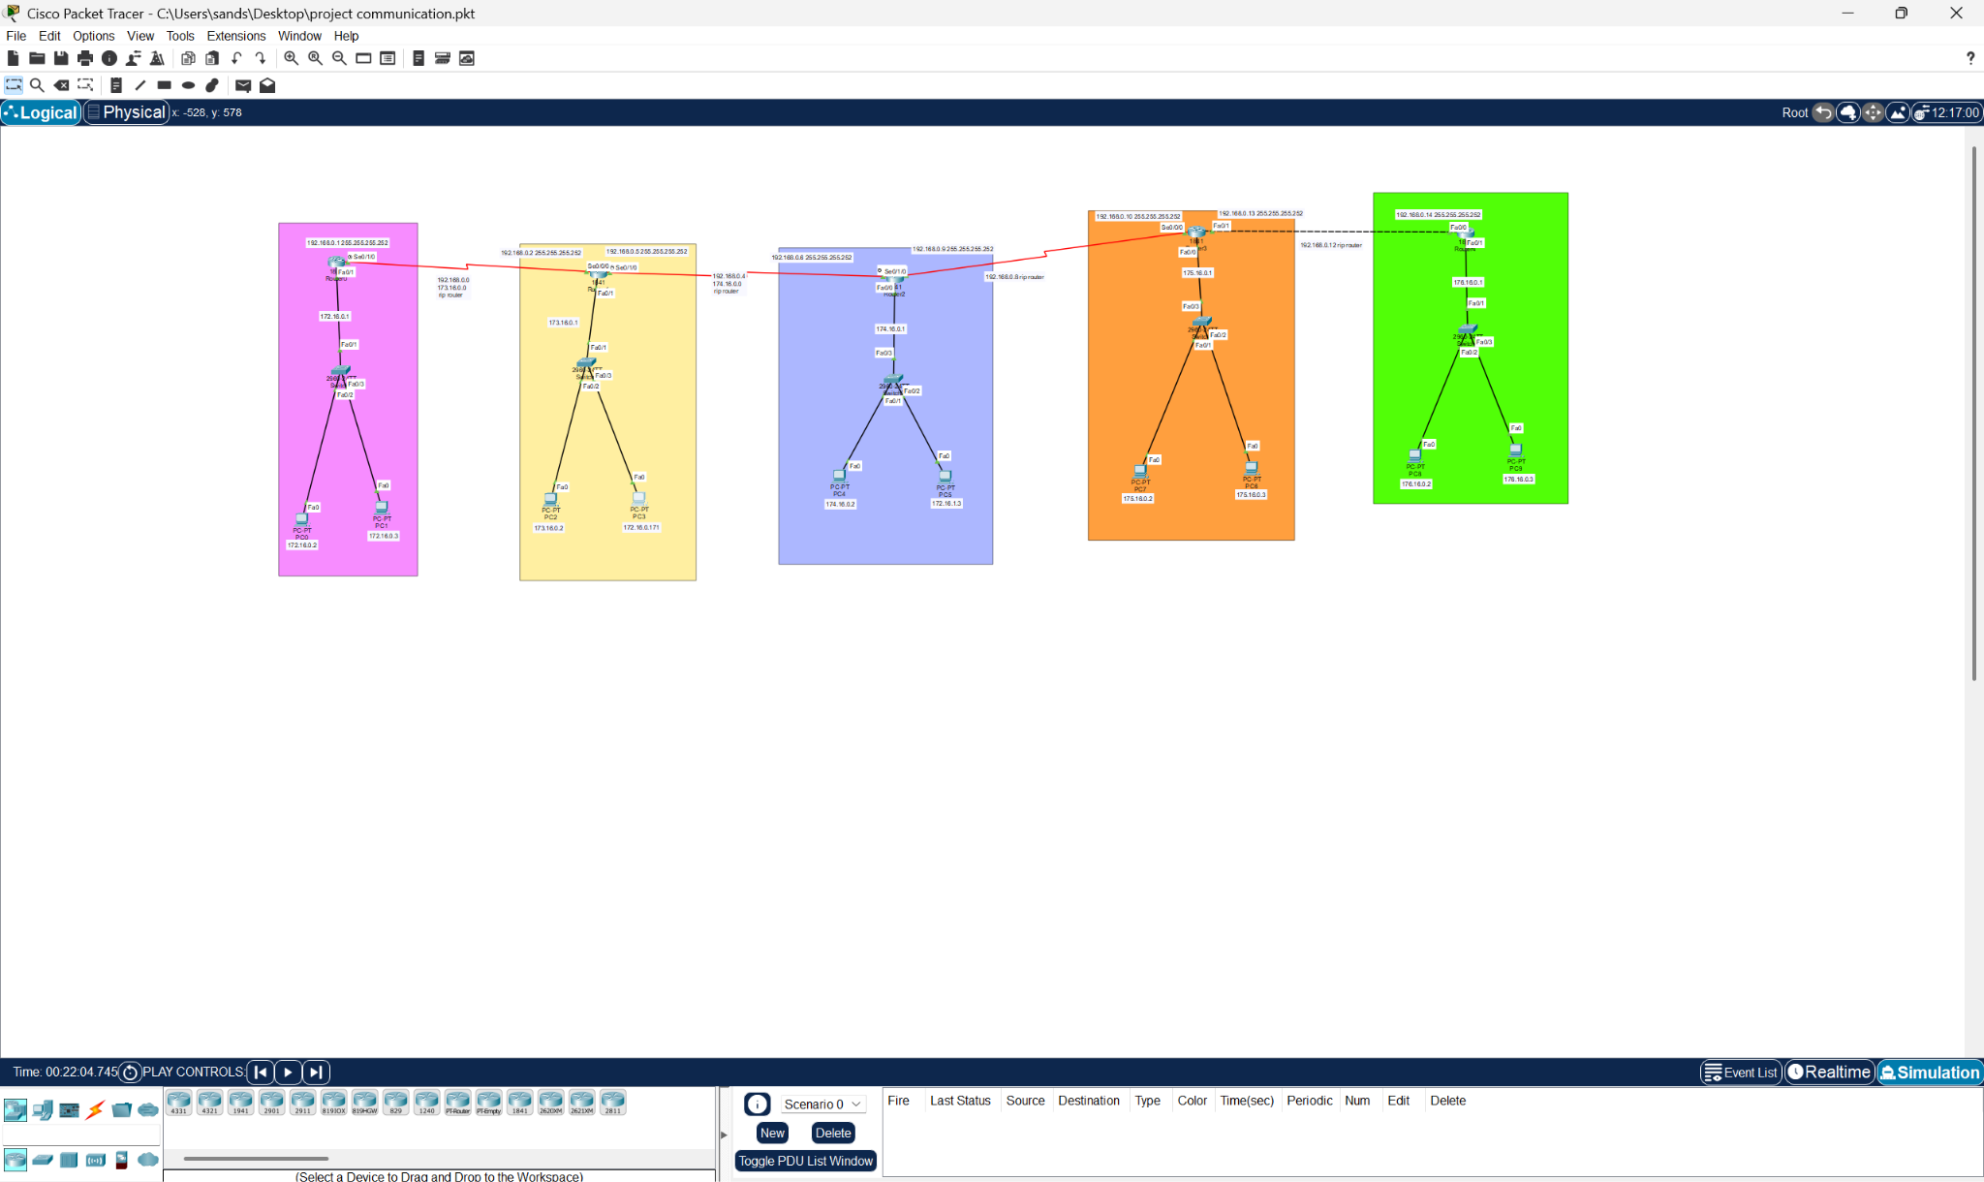

6. Connectivity Testing and Verification
Include ping test results, routing tables (`show ip route`), and traceroutes between subnets.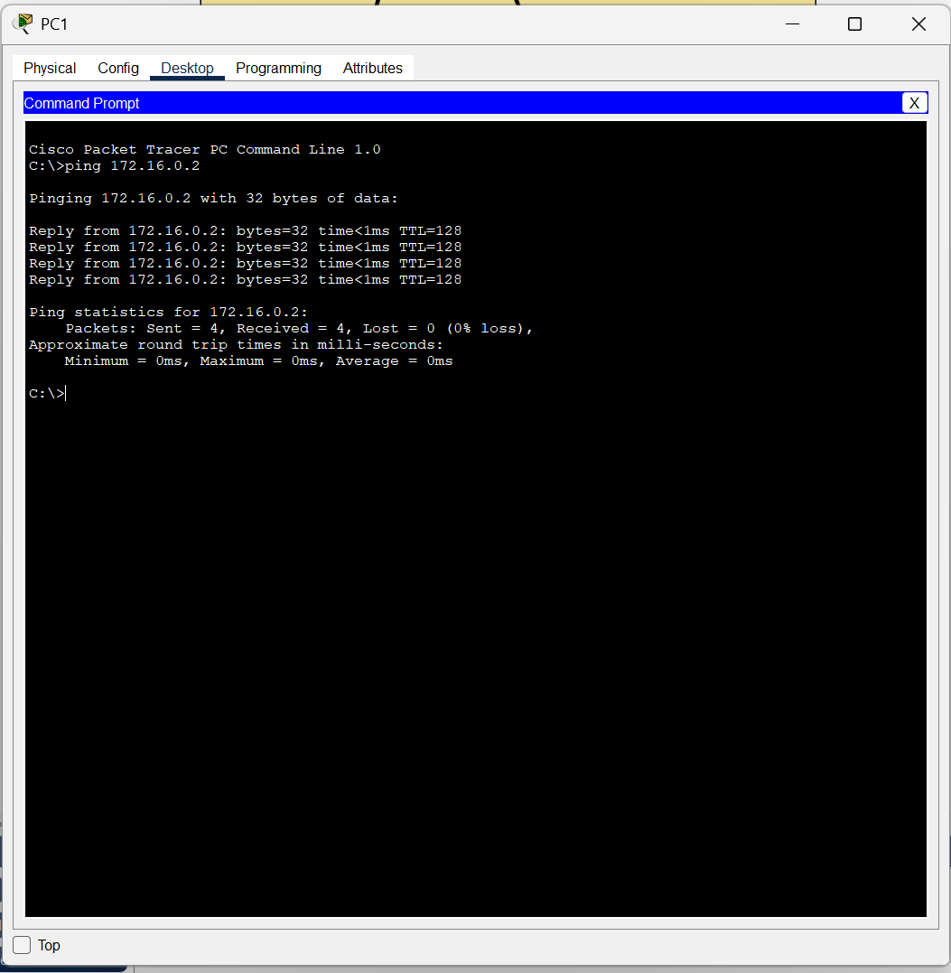

7. Screenshots of Configuration and Tests
Paste annotated screenshots showing:
- Router interface configurations
- Routing protocol setup
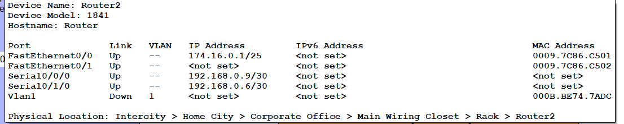
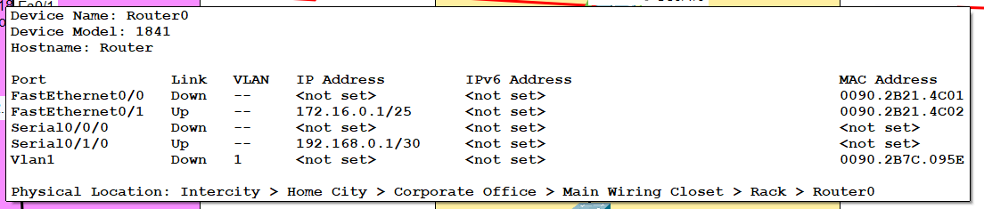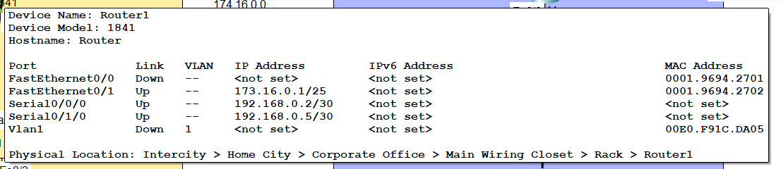
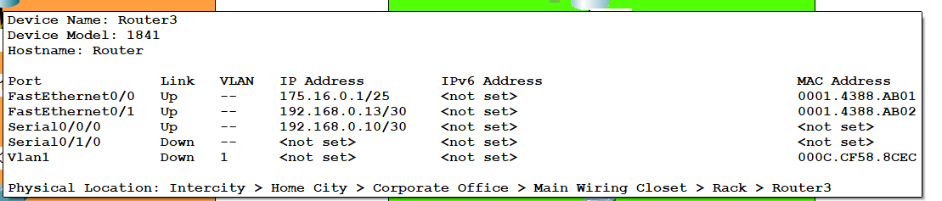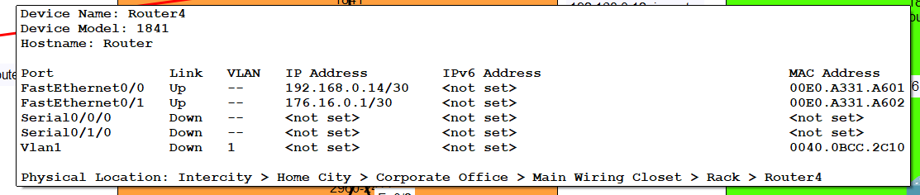
- Successful pings between PCs in different subnets
- Routing table outputs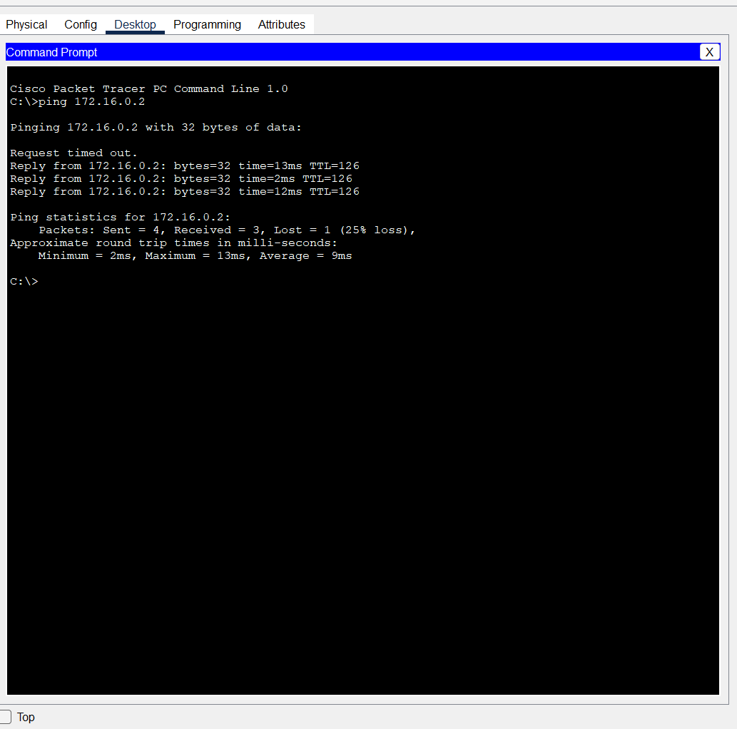

8. Export Router Configurations, and paste them below. (click on every router, and click on the export button to extract its configurations)
